/\* List the name, position, and salary of employees’ branch BR08, and arrange the list

alphabetically according to the names.\*/

use RentalSystem

select \* from Employee;

select FirstName,LastName,Position,Salary from employee where BranchID = 'BR08'

order by FirstName,LastName ASC;

/\*List the details of employees who work at branch that is based in Johor state\*/

select \* from Employee where city = 'Johor Bahru';

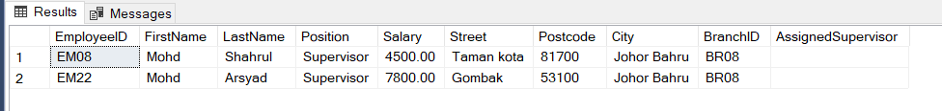

/\*List the type of the property and the business owner’s name, for all property in which

the property type is Bungalow with number of rooms that is more than 5.\*/

select TypeOfOwner,FirstName,LastName from OwnerInfo where OwnerID in (select OwnerID from property where TypeOfHouse = 'Bungalow' AND NoOfrooms > '5');

